 | CFAS Enterprises Inc.  After Market Utility Power Equipment Brokerage  Mailto:Staff@CFASPower.com  Turbine URL: http://CFASPower.com/Index.html  Reciprocating URL: http://CFASPower.com/Recips.html
GTG_16??DMCI_Fm6CC_50Hz.doc

1 x Used 2 On 1 PG6531B 110MW COMBINED CYCLE 50Hz POWER PLANT

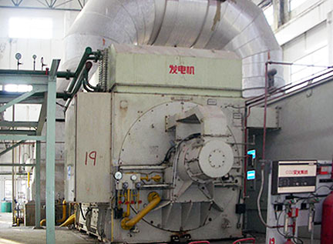

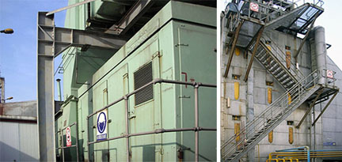

Asking Price: FOB $7,250,000,

a. The Proposed Power Plant operated since 1992 and shut down in 2008 due to China’s energy policy. All necessary equipment are complete and in very good condition.
b. Two sets of PG6531B gas turbines, output 37.18MW; one set of ENKS63/2.8 steam turbine, output 34MW; two Waste Heat Recovery Boilers (WHRB).
c. Gas Turbines manufactured by John Brown Engineering Gas Turbines LTD (JBE); Steam Turbine manufactured by SIEMENS; WHRB manufactured by Holland STANDARD FASEL LENTJES.
d. #1 gas turbine runs for 50,279.3 hours; #2 gas turbine runs for 50,034.9 hours; steam turbine runs for 48,373.2 hours.
e. Voltage 10500v; frequency 50Hz; speed 3,000rpm

Parameter and Running Situation of Main Equipment

1. PG6531B gas turbine (1# unit)

Manufacturer: Britain JBE Company;
Fuel: natural gas, light oil, heavy oil
Output power of power generator: 37.18MW;
Axial flow air compressor: rotation speed 5100rpm, pressure ratio 14, grade 17;
Tube reverse-flow type combustion chamber: 10 pieces;
Turbine: rotation speed 5100rpm, grade 3, intake temperature 1200℃, exhaust gas temperature 543℃, exhaust flow 134.8kg/s; thermal efficiency 32.32%.
I# gas turbine runs for 50279.3 hours (including 23232.3 hours of fuel oil and 27047 hours of fuel gas), starts for 781 times

2. PG6531B gas turbine ( 2# unit)

Manufacturer: Britain JBE Company;
Fuel: natural gas, light oil, heavy oil
Output power of power generator: 37.18MW;
Axial flow air compressor: rotation speed 5100rpm, pressure ratio 14, grade 17;
Tube reverse-flow type combustion chamber: 10 pieces;
Turbine: rotation speed 5100rpm, grade 3, intake temperature 1200℃, exhaust gas temperature 543℃, exhaust flow 134.8kg/s; thermal efficiency 32.32%.
2# gas turbine runs for 50034.9 hours (including 23988.6 hours of fuel oil and 26046.3 hours of fuel gas), starts for 560 times

3. ENKS63/2.8 steam turbine (3# unit)

Manufacturer: SIEMENS Company; Design power: 34MW;
Rotation speed: 3000rpm; Main steam pressure: 3.9MPa;
Exhaust steam pressure: 0.0065MPa; Main steam temperature: 440℃;
Steam flow: 132t/h; Extraction pressure: 0.15 MPa;
3# steam turbine runs for 48373.2 hours

4. 1#, 2# exhaust-heat boiler

Manufacturer: Holland STAND FASEL LENTJES;
Type: horizontal type, not after-burning, natural circulation, single pressure, outdoor arrangement;
Design pressure: 4.6MPa; Main steam temperature: 453℃;
Evaporation capacity: 66 t/h; Water feeding temperature: 104℃;

